Exercise 1: Control Structures

**Scenario 1:** The bank wants to apply a discount to loan interest rates for customers above 60 years old.

* + **Question:** Write a PL/SQL block that loops through all customers, checks their age, and if they are above 60, apply a 1% discount to their current loan interest rates.

*SOURCE CODE :*

**SET SERVEROUTPUT ON;**

**DECLARE**

**CURSOR senior_discount_cur IS**

**SELECT l.LoanID, l.InterestRate, c.CustomerID, c.DOB**

**FROM Loans l**

**JOIN Customers c ON l.CustomerID = c.CustomerID;**

**v_age NUMBER;**

**BEGIN**

**FOR rec IN senior_discount_cur LOOP**

**-- Calculate age**

**v_age := TRUNC(MONTHS_BETWEEN(SYSDATE, rec.DOB) / 12);**

**IF v_age > 60 THEN**

**UPDATE Loans**

**SET InterestRate = InterestRate - 1**

**WHERE LoanID = rec.LoanID;**

**END IF;**

**END LOOP;**

**COMMIT;**

**DBMS_OUTPUT.PUT_LINE('Discount applied to customers over 60.');**

**END;**

**/**

OUTPUT :   
  
  
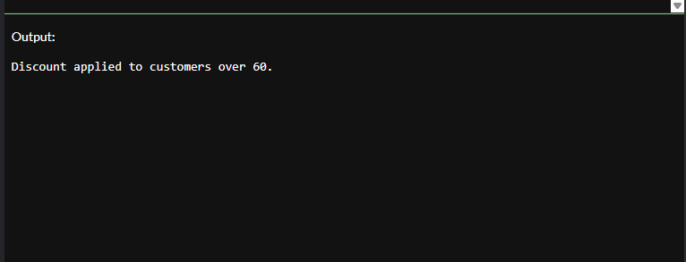

**Scenario 2:** A customer can be promoted to VIP status based on their balance.

* + **Question:** Write a PL/SQL block that iterates through all customers and sets a flag IsVIP to TRUE for those with a balance over $10,000.

***SOURCE CODE :***

SET SERVEROUTPUT ON;

DECLARE

CURSOR cur_vip IS

SELECT CustomerID, Name, Balance

FROM Customers;

BEGIN

FOR rec IN cur_vip LOOP

IF rec.Balance > 10000 THEN

UPDATE Customers

SET LastModified = SYSDATE

WHERE CustomerID = rec.CustomerID;

DBMS_OUTPUT.PUT_LINE('Customer ' || rec.Name || ' promoted to VIP.');

END IF;

END LOOP;

COMMIT;

END;

/

***OUTPUT :***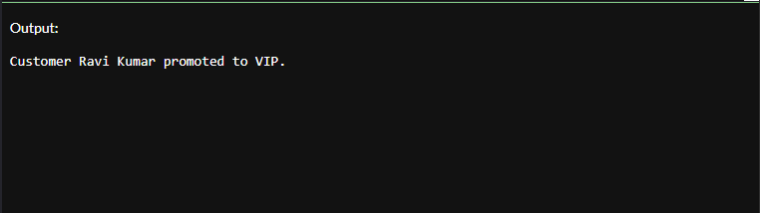

**Scenario 3:** The bank wants to send reminders to customers whose loans are due within the next 30 days.

* + **Question:** Write a PL/SQL block that fetches all loans due in the next 30 days and prints a reminder message for each customer.

***SOURCE CODE :***   
  
SET SERVEROUTPUT ON;

DECLARE

CURSOR cur_due_loans IS

SELECT l.LoanID, c.Name AS CustomerName, l.EndDate

FROM Loans l

JOIN Customers c ON l.CustomerID = c.CustomerID

WHERE l.EndDate BETWEEN SYSDATE AND SYSDATE + 30;

BEGIN

FOR rec IN cur_due_loans LOOP

DBMS_OUTPUT.PUT_LINE('Reminder: Loan ID ' || rec.LoanID ||

' for customer ' || rec.CustomerName ||

' is due on ' || TO_CHAR(rec.EndDate, 'DD-MON-YYYY'));

END LOOP;

END;

/

OUTPUT :